# ShoreFor GUI Example

# September 15, 2014

# *Tomas Beuzen t.beuzen@unsw.edu.au*

# Preface

In this example we will analyse a sample data set using the ShoreFor GUI. This example does not explain the functionalities or context of the model. Please see the model user guide for further information.

# Example

1. Open the **‘GUI_ShoreFor’** application, it may take several seconds to open. You will be presented with the following screen;

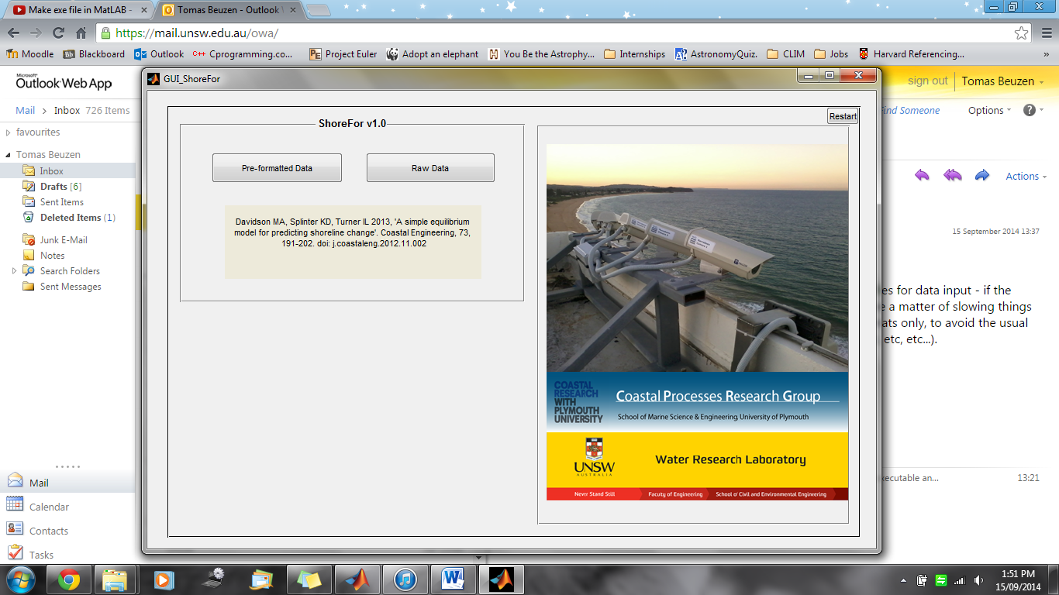

1. Select **Raw Data**
2. Click the **Select Wave data file**. A dialogue box will open, locate and select the file **sample_waveData.mat**.
3. Click the **Select Shoreline data file**. A dialogue box will open, locate and select the file **sample_shorelineData.mat**.
4. Click **Ok**, a number of drop down menus will appear below.
5. Select data from the drop down menus as follows;

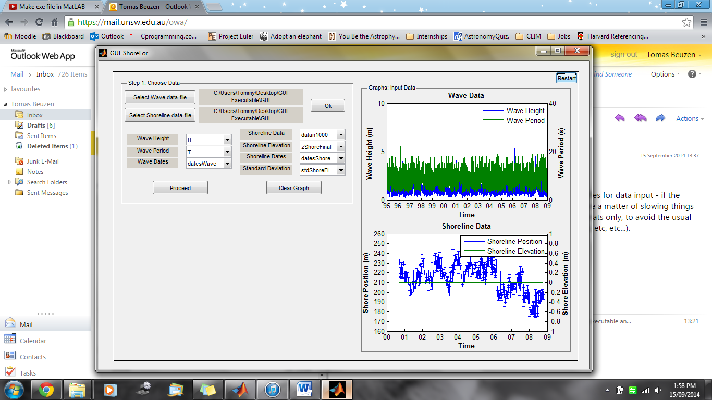

1. Click **Ok**. Then click **Proceed**. A new panel will appear in the bottom left corner.
2. Complete the panel as desired. An example is shown below;

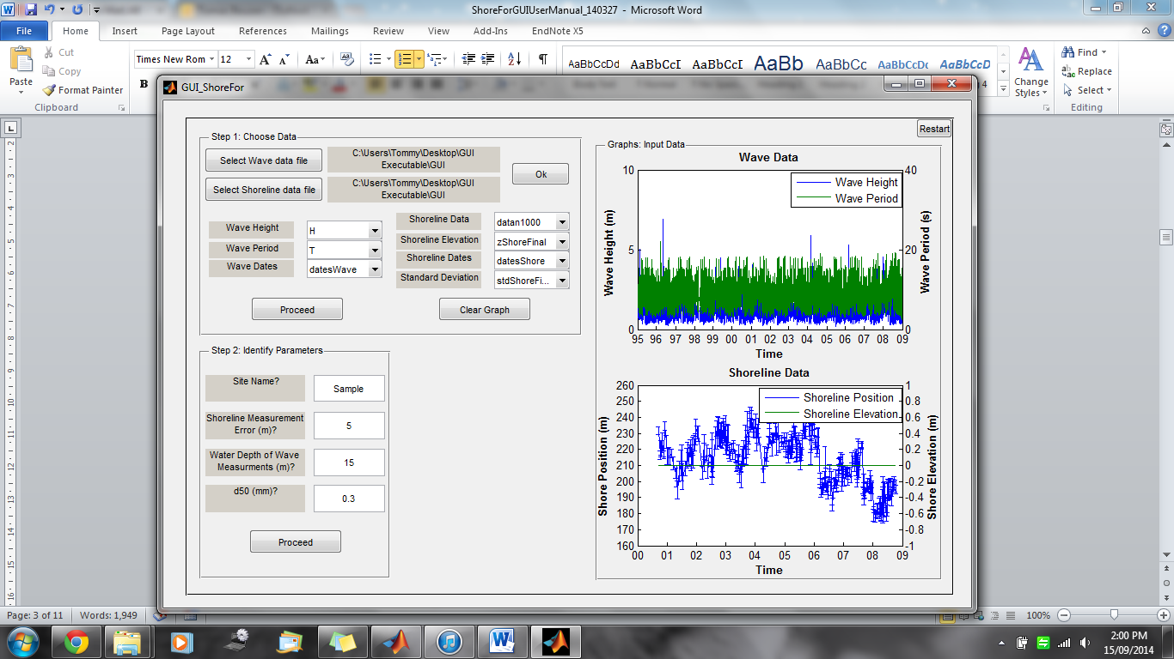

1. Click **Proceed**. A new panel will appear to the right.
2. Check the box next to **Full Data**. Click **Proceed**. A new panel will appear.
3. On the new panel, select **Optimise**. Click **Proceed**. A new panel will appear.
4. This is the final panel, select as many or as few results to be displayed as desired.
5. Click **Run Model**.